

University of Pisa

# Brain Tumor Classifier

## An application of Deep Learning techniques for the classification of brain tumors from MRI

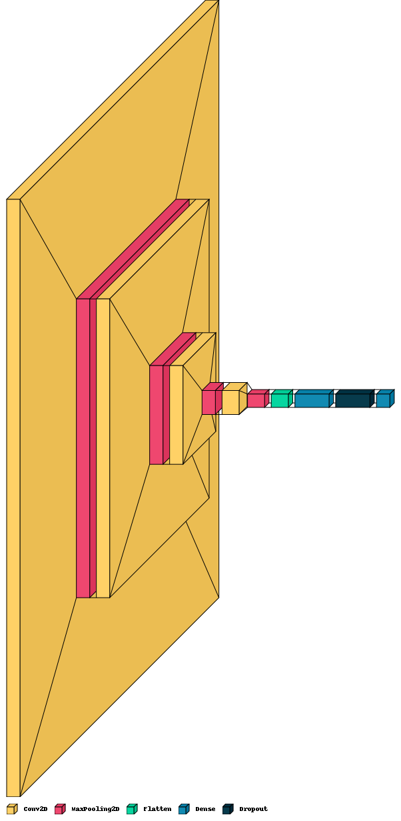

Di Donato Mattia, Giorgi Matteo

Sommario

Brain Tumor Classifier 1

*An application of Deep Learning techniques for the classification of brain tumors from MRI* 1

Abstract 4

Dataset 4

Methods and Experiments 5

Data Preprocessing 5

CNN from scratch 5

Pretrained models 5

VGG16 5

ResNet50 5

InceptionV3 5

Explainability 5

Intermediate Activations 5

CNN from scratch 5

VGG16 5

ResNet50 5

InceptionV3 5

Heatmap for Meningioma Tumor 5

Heatmap for No Tumor 5

Conclusions 5

# Abstract

Brain tumors are recognized as highly aggressive diseases, affecting both children and adults. They account for a significant majority, ranging from 85% to 90% of all primary Central Nervous System (CNS) tumors. Annually, approximately 11,700 individuals receive a diagnosis of a brain tumor. The 5-year survival rates for cancerous brain or CNS tumors are estimated at around 34% for men and 36% for women. Given the gravity of this condition, it is imperative to employ proper treatment strategies, meticulous planning, and precise diagnostic methods to enhance the life expectancy of affected patients.

Among the various techniques available for brain tumor detection, Magnetic Resonance Imaging (MRI) stands out as the most effective modality. A huge number of images are generated through scans and they are examined by radiologists. A manual examination can be error-prone due to the level of complexities involved in brain tumors and their properties.  
Application of automated classification techniques using Deep Learning Algorithms for instance Convolution Neural Network (CNN) and Transfer Learning (TL) have gained considerable attention as they would help doctors in the detection of this disease improving accuracy and efficiency.

# Dataset

The dataset used for the realization of this application is taken from Kaggle (<https://www.kaggle.com/datasets/sartajbhuvaji/brain-tumor-classification-mri>).

It has a dimension of 90MB and is a collection of 3264 MRI (gray scale) of different resolution. These images have been classified by experts and have been divided into 4 categories with the related support 'glioma_tumor': 926, 'meningioma_tumor': 937, 'no_tumor': 500, 'pituitary_tumor': 901, these are some sample images from it.

# Methods and Experiments

## Data Preprocessing

## CNN from scratch

## Pretrained models

### VGG16

### ResNet50

### InceptionV3

# Explainability

## Intermediate Activations

### CNN from scratch

### VGG16

### ResNet50

### InceptionV3

## Heatmap for Meningioma Tumor

## Heatmap for No Tumor

# Conclusions